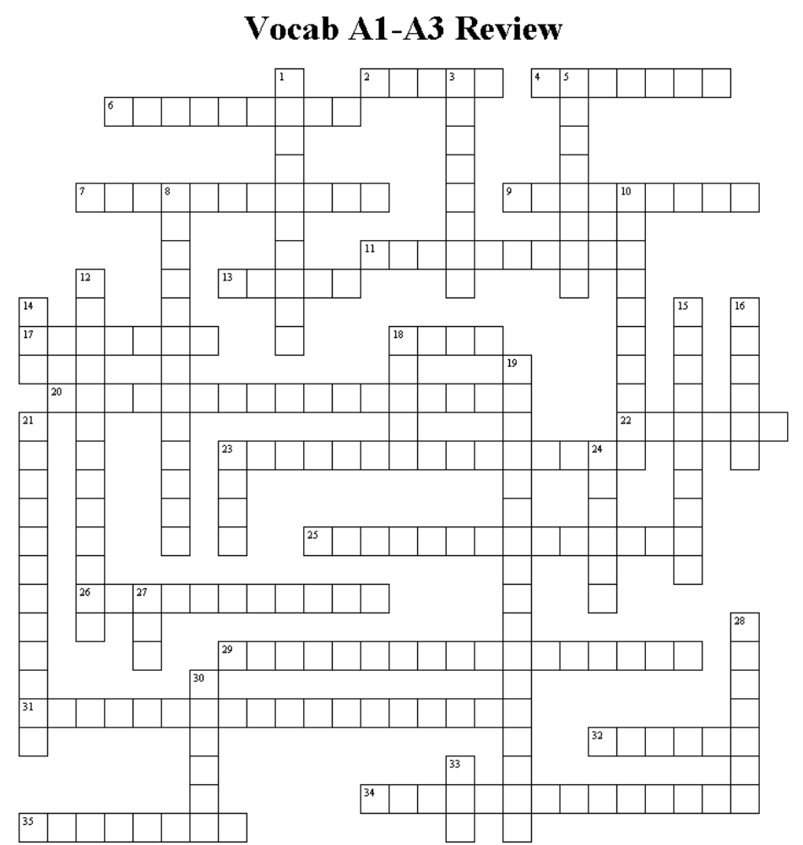WORKSHEET A3.4

ACROSS
2 A standard set of two byte codes which represent characters. It stands for American Standard Code for Information Interchange.
4 A collection of related classes.
6 Parts of a class that define what objects of that class can do. The methods within a class.
7 Methods of a class that define how objects of that class are created.
9 The process of converting Java code into byte code that can then be understood by the Java interpreter.
11 A set of rules that defines in what order operators are evaluated.
13 A primitive data type that represents numbers with a decimal point. It cannot hold numbers as large or as precise as a double, but it takes up less memory.
17 Information and instructions passed between objects.
18 A primitive data type that represents an ASCII character.
20 Basic items that are not objects.
22 A software program that allows a programmer to type in code. Modern versions usually make it easy to format the code on the screen.
23 The operator (%) that returns the remainder of dividing the left expression by the right expression.
25 Special characters that are interpreted differently than they appear in code. These are generally used for carriage returns (\n), tabs (\t), and quotes (\") within string literals.
26 A specialized class whose only purpose is to instantiate the initial objects of a program and start the interactions within.
29 The operator (++) that increases the value of a numerical variable by one.
31 The equal sign (=). It copies the value on the right to the variable on the left.
32 A primitive data type that represents numbers with a decimal point. It can represent larger numbers and has more precision than float, but it takes up more memory.
34 A way of changing from one primitive data type to another.
35 Text within source code that is ignored by the compiler and is used to make notes about the workings of the class.

DOWN
1 The text that a programmer types into the computer and that the Java compiler can convert into byte code.
3 An object of a class.
5 A value that appears in a call to a method.
8 Text enclosed by double quotes.
10 A name given to a variable, method, or class.
12 Words in Java that have special meaning and therefore cannot be used as identifiers.
14 Standards used when designing OO systems. It stands for Unified Modeling Language.
15 Parts of a class that contain the current state of objects of that class. The member variables of a class.
16 Sections of code that perform some action defined by a class.
18 A list of specifications that define a certain type of object and can be used to create objects of that type.
19 The operator (--) that decreases the value of a numerical variable by one.
21 A visual representation of the relationships between classes.
23 A method that is the starting point for a program. Every Java program must have one to run, but most objects should not contain one.
24 The basic building block of OOP, defined by classes and then instantiated within a program to solve parts of a larger problem.
27 A primitive data type that represents whole numbers.
28 A primitive data type that represents either true or false.
30 Keyword that allows a programmer to access pre-made classes and packages.
33 Keyword used to create objects.

